- Richard Newton Distinguished Innovator Lecture Series

Course Syllabus Spring 2018 INDENG 95/195/295 (1 Credit – Class # 36315/36334/36367)
The Pantas and Ting Sutardja Center for Enterpreneurship & Technology (SCET)

The Pantas and Ting Sutardja Center for Entrepreneurship & Technology hosts the A. Richard Newton Distinguished Innovator Lecture Series and is the premiere institution on the UC Berkeley campus for the study and practice of “technology- centric” entrepreneurship and innovation. Since 2005, SCET has been central to Berkeley’s entrepreneurship ecosystem.

SCET is also known for developing the Berkeley Method of Entrepreneurship, an internationally recognized approach to teaching technology entrepreneurship for undergraduates, innovation for Ph.D. students, and technology firm leadership for professionals and executives. As part of the Berkeley innovation ecosystem, SCET also collaborates closely with the Jacob’s Institute for Design, the Haas Business School, and CITRIS Foundry.

If you are interested in new Ventures or innovation on the Berkeley campus or anywhere in the world, the Sutardja Center is the place to be. The Center is located (at the Stadium) within the College of Engineering of UC Berkeley and its academic home is the Department Industrial Engineering & Operations Research. For more information, visit our website at scet.berkeley.edu.

Program Description
This lecture series serves as an entry point for undergraduate and graduate curriculum sequences in entrepreneurship and innovation. The series, established in 2005 is named in honor of A. Richard Newton, former Dean, UC Berkeley College of Engineering. In addition to his academic role, Newton played an active role in industry, helping to found a number of design technology companies including SDA Systems (now Cadence Design Systems), Synopsys, PIE Design Systems (now part of Cadence), Simplex Solutions and Crossbow.

The course features a selection of high-level speakers, from industry, academia and media, who share their insights on industry developments, leadership and innovation based on their careers. Classes are held in a variety of learning formats, from lecture to fireside chat to panel discussion and, on occasion film-screening. Our objective is to expose students to multiple elements key to innovation and entrepreneurship through the unique opportunity of seeing and hearing insights and viewpoints, from diverse speakers, from varying industries and with different expertise.
We meet once a week (with few exceptions) in Li Ka Shing Auditorium, on Tuesdays 6:30pm - 8:00pm. Any exceptions will be emailed and included as part of B-course announcements. For a passing grade and 1-credit, attendance is mandatory, as are weekly post-class feedback forms. Also, each student will participate in a group project, submitting a written report or presentation. Attendance, completed feedback forms and project submissions are the three elements needed to pass and receive 1 credit this pass/fail course.

In addition to this mandatory portion, there is opportunity to provide questions to speakers, live during our class Q&A; and depending on speaker availability, a chance to interact one-on-one after class. Students are offered the chance to introduce select speakers. Finally, based on your group report submission, you may be asked/chosen to present your findings to the class toward the end of the semester.
Lead TA: Travis Brashears - Ask him questions related to grading, attendance, speaking opportunities, and anything logistical about the class. trbrashears@berkeley.edu

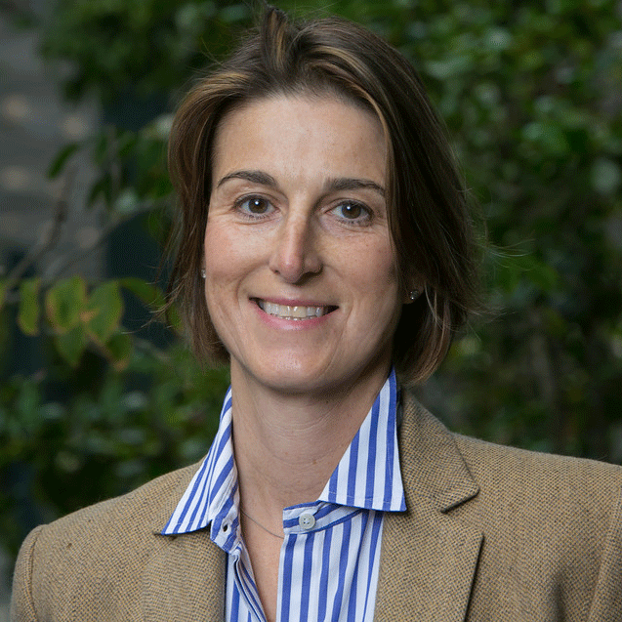Instructor: Victoria Howell, vhowell@berkeley.edu

SCHEDULE – SPRING SPEAKERS

 | Course overview with Victoria Howell, associate instructor and…  A New Perspective on Meat with Prof. A.J. van der Goot, Wageningen University in The Netherlands | 01.16.18 @6:30pm in Li Ka Shing Auditorium
 | Course overview with Victoria Howell, associate instructor and …  What is an Entrepreneur? with Shounan Chen, founder and general partner, Agile VC and President, NA Blockchain Association | 01.23.18 @6:30pm in Li Ka Shing Auditorium
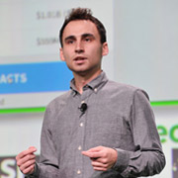 | NEWTON KICKOFF KEYNOTE – Newton Kickoff with Cal grad, Nikita Bier, cofounder, tbh, recently acquired by Facebook with introduction from Jeremy Fiance, managing partner, The House Fund | 01.30.18 @6:30pm in Li Ka Shing Auditorium
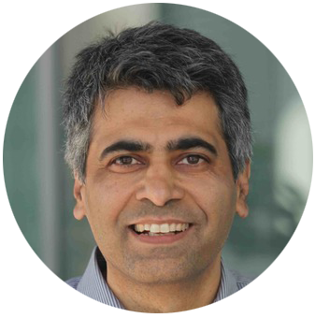 | Critical Skills and Mindset for Starting Out in Innovation & Entrepreneurship with  Ikhlaq Sidhu, founding director and chief scientist, Sutardja Center for Entrepreneurship and Technology, and IEOR Emerging Industry Professor  and  Rahim Fazal, cofounder, Involver (acquired by Oracle) and SV Academy | 02.06.18 @6:30pm in Li Ka Shing Auditorium
 | The Biology of Belonging and Company Culture with Cal grad, Janet Crawford, founder, Cascadance, Inc. helping leaders foster productive, innovative and collaborative cultures  and  Team Formation Exercise (important to attend) | 02.13.18 @6:30pm in Li Ka Shing Auditorium
 | Michael Seibel, partner and CEO, Y Combinator | 02.20.18 @6:30pm in Li Ka Shing Auditorium
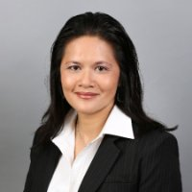 | Cal Grad, Mai Le, Head of Business Platform Engineering, Uber. For 15+ years, she has been leading organizational, cultural and technical transformations holding senior leadership roles at Yahoo, Walmart, Microsoft, and Symantec | 02.27.18 @6:30pm in Li Ka Shing Auditorium
 | Cal grad, Forrest Iandola, CEO and cofounder DeepScale | 03.06.18 @6:30pm in Li Ka Shing Auditorium
 | The Importance of Failure, panel discussion led by Cal grad, Amit Kumar, partner, Accel Ventures | 03.13.18 @6:30pm in Li Ka Shing Auditorium
 | Cal Grad, Alex Stamos, CSO, Facebook | 03.20.18 @6:30pm in Li Ka Shing Auditorium
 | NO CLASS. SPRING BREAK | 03.27.18
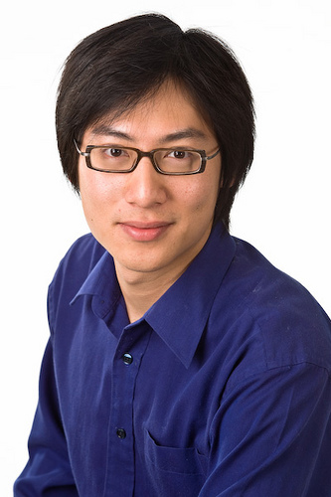 | Empowering You to Change the World with Cal grad, Jerry Luk, cofounder, Presdo and Loop | 04.03.18 @6:30pm in Li Ka Shing Auditorium
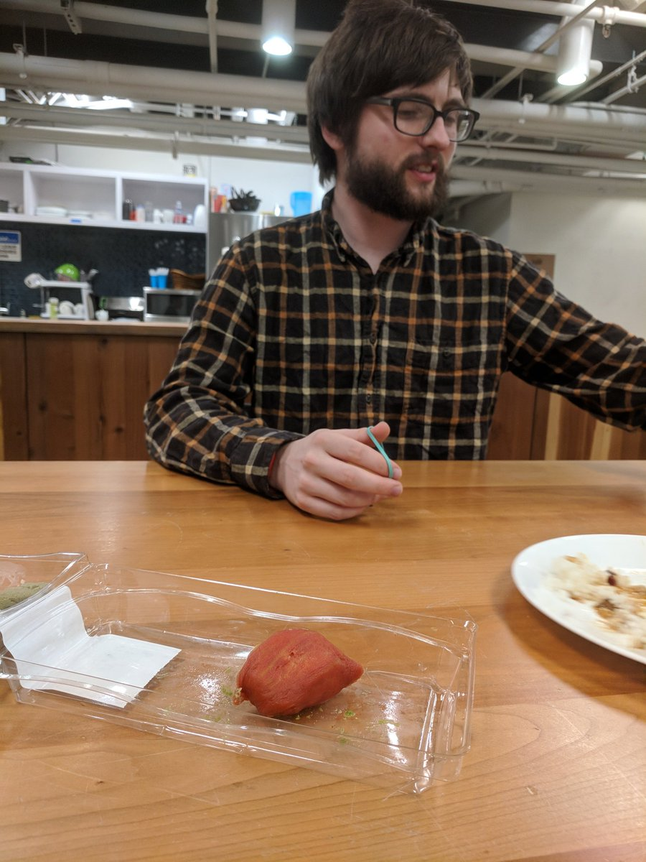 | Cal grads, Kimberlie Le & Joshua Nixon, cofounders, Terramino Foods, cooking up the future of protein | 04.10.18 @6:30pm in Li Ka Shing Auditorium
 | Group Papers/Presentations Due and Speaker to be announced | 04.17.18 @6:30pm in Li Ka Shing Auditorium
 | NEWTON CLOSING KEYNOTE –  Dr. Joyce Tung, VP, Research, 23andMe | 04.24.18 @6:30pm in Li Ka Shing Auditorium

CONTACT INFORMATION

Instructors: | Victoria Howell | vhowell@berkeley.edu
GSI (Questions on Attendance, Grading, Reports, Absences): | Travis Brashears | (trbrashears@berkeley.edu)

OFFICE HOURS & COMMUNICATIONS

Contact Travis Brashears ((trbrashears@berkeley.edu) for class-related questions, to schedule an office appointment. All communications available via B-course.

FORMAT

The course is a series of in-person lectures from leading innovators and entrepreneurs.Unless otherwise noted (via email and on b-course), classes take place each Tuesday, in Li Ka Shing Auditorium from 6:30pm – 8:00pm. There are three mandatory elements to this class and needed for a passing grade:
- Attendance is mandatory (Please note that it is not acceptable to arrive past 6:45pm, nor to leave early unless you have offered a written excuse prior to class. See policy for any absences below.
- Post class feedback forms (electronic) are mandatory.
- Group project due at the end of the semester (April 17th, 2018). Details to be provided midway through the course, with one class dedicated to creating project teams. If you are not in class that day, please follow-up with the GSI for your class project assignment and check for updates on b-course. Select projects will be chosen for in-class presentation, before the end of the semester.

There are also optional elements to the class as follows:
- You may be eligible to introduce one of our speakers
- You are encouraged to ask questions, during the Q&A period after the lecture, chat or panel.
- You may approach the stage, depending on speaker availability for a one-on-one interaction with the speaker/speakers

TOPICS COVERED
Leading entrepreneurs and innovators provide career insights, life lessons and their perspective on innovation in their field. Speakers are invited based on their contributions, diverse backgrounds and various perspectives on innovation and entrepreneurship.

CREDIT
This is a one-credit course, offered either for a grade or pass/fail. Passing marks and grades are based on mandatory in-person lecture attendance, completion of lecture feedback forms and report or project due at the end of the semester.

TEXTS AND REQUIRED SUPPLIES
In addition to in-person lectures, it’s recommended that students familiarize themselves with each week’s speaker and his/her business topic area prior to the speaking date.

GRADING & ATTENDANCE
65% - Attendance is mandatory and will be measured either via ID scan, “sign-in” sheets, , electronic survey submissions due after each lecture or a combination
35% - Mandatory group report/project. To be clarified during the semester.

ATTENDANCE POLICY

Attendance is mandatory for a passing grade. Please note: Excused absences must be submitted to our GSI in writing prior to or within 24 hours of the lecture. Each absence will be judged on a case–by–case basis, and you will receive instructions. If you cannot attend, submit a written excuse, prior to the lecture, or within 24 hours to:

Travis Brashears (trbrashears@berkeley.edu)

Each unexcused absence will drop you one grade, for example from A to B, B to C. If you have a C for attendance you will not pass the class.

DATES & LOCATION

Students are to reserve Tuesday evenings, 6:30pm – 8:00pm. For the Spring semester our lectures will take place on campus at Li Ka Shing Auditorium, at Hearst/Oxford. Please see b-course for updates.

