- Richard Newton Distinguished Innovator Lecture Series
Course Syllabus Fall 2019 INDENG 95/195/295 (1 Credit – Class #28126/19469/19470)
The Pantas and Ting Sutardja Center for Entrepreneurship & Technology (SCET)

The Pantas and Ting Sutardja Center for Entrepreneurship & Technology hosts the A. Richard Newton Distinguished Innovator Lecture Series and is the premiere institution on the UC Berkeley campus for the study and practice of “technology- centric” entrepreneurship and innovation. Since 2005, SCET has been central to Berkeley’s entrepreneurship ecosystem.

SCET is also known for developing the Berkeley Method of Entrepreneurship, an internationally recognized approach to teaching technology entrepreneurship for undergraduates, innovation for Ph.D. students, and technology firm leadership for professionals and executives. As part of the Berkeley innovation ecosystem, SCET also collaborates closely with the Jacob’s Institute for Design, the Haas Business School, and CITRIS Foundry.

If you are interested in new ventures or innovation on the Berkeley campus or anywhere in the world, the Sutardja Center is the place to be. The Center is located within the College of Engineering of UC Berkeley (at the Stadium) and its academic home is within the Department Industrial Engineering & Operations Research. For more information, visit our website at scet.berkeley.edu.

Program Description
This lecture series (see more on website as well as view video archives - (https://scet.berkeley.edu/newton-series/) serves as an entry point for undergraduate and graduate curriculum sequences in entrepreneurship and innovation. The series is named in honor of A. Richard Newton, former Dean, UC Berkeley College of Engineering. In addition to his academic role, Newton played an active role in industry, helping to found a number of design technology companies including SDA Systems (now Cadence Design Systems), Synopsys, PIE Design Systems (now part of Cadence), Simplex Solutions and Crossbow.

The course features a selection of high-level speakers, from industry, academia and media, who share their insights on industry developments, leadership and innovation based on their careers. Classes are held in a variety of learning formats, from lecture to fireside chat to panel discussion and, on occasion film-screening. Our objective is to expose students to multiple elements key to innovation and entrepreneurship through the unique opportunity of seeing and hearing insights and viewpoints, from diverse speakers, from varying industries and with different expertise.

Grading for Pass/Fail and Additional Opportunities (no letter grades)
We meet once a week (with few exceptions) in Li Ka Shing Auditorium, on Tuesdays 6:30pm - 8:00pm. Any exceptions will be emailed and included as part of B-course announcements. For a passing grade and 1-credit, attendance is mandatory, as are weekly post-class feedback forms. Also, each student will submit a group project/written reflection at the end of the semester. Attendance completed feedback forms and reflection, or project submissions are the three elements needed to pass and receive 1 credit this pass/fail course. There are a limited numbed (2) of allowable excused absences, but to be considered, on a case by case basis, you must email the instructor or Student Coordinator prior to class.

In addition to this mandatory portion, there is opportunity to provide questions to speakers, live during our class Q&A; and depending on speaker availability, a chance to interact one-on-one after class. Students are also offered the chance to introduce select speakers.

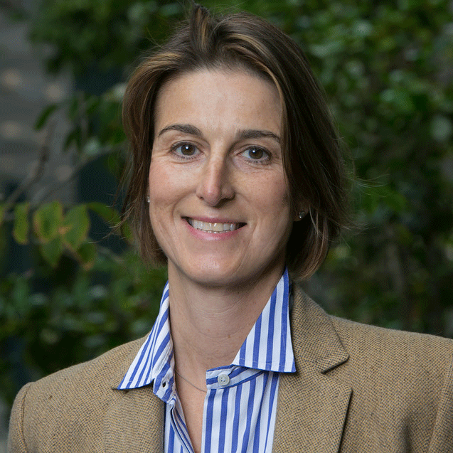 Instructors: Victoria Howell, vhowell@berkeley.edu. Feel free to reach out for questions, speaker intros, entrepreneurial advice, mentoring, networking or suggestions for The Series. In addition, we are fortunate to have IEOR Department Chair, Dr. Max Shen as part of the Instructor Team.

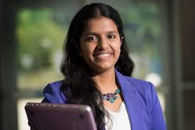 Lead Student Coordinator: Swetha Prabakaran - swethapraba+newton@berkeley.edu. Ask her questions related to grading, attendance, speaking opportunities and anything logistical about the class.

SCHEDULE – SPRING 2019 SPEAKERS
 | ORIENTATION, Victoria Howell, Associate Instructor | 09.03.19 @6:30pm in Li Ka Shing Auditorium
 | NEWTON KICKOFF KEYNOTE  Cal grad, Charlie Giancarlo, Chairman and CEO at Pure Storage, the data storage company that helps innovators leverage their data, use artificial intelligence and modern analytics to build a better world. He is an Internet Pioneer, Entrepreneur, Investor, and former senior executive of a Fortune 50 high tech company (Cisco). | 09.10.19 @6:30pm in Li Ka Shing Auditorium
 | Dr. Mary Lou Jepsen, founder, Openwater, the high resolution camera for the body. Former engineering executive at Facebook, Oculus Google [x] and Intel. Founder of four startups including One Laptop per Child. Time 100 most influential people in the world, CNN top 10 thinker and Forbes top 50 women in technology. | 09.17.19 @6:30pm in Li Ka Shing Auditorium
 | Cal grad, Han-Shen (Han) Yuan, Engineering SVP Upwork, the world's largest freelancer marketplace. Former senior engineer at eBay. | 09.24.19 @6:30pm in Li Ka Shing Auditorium
 | Networking Seminar & Project Outline for ½ of class | 10.01.19 @6:30pm in Li Ka Shing Auditorium
 | Networking Seminar & Project Outline for other ½ of class | 10.08.19 @6:30pm in Li Ka Shing Auditorium
 | Ana Arriola, GM and partner, Microsoft AI + Research & Search. Former design executive at Facebook, Samsung, Apple, Sony and notably at Theranos, where her influence was featured in the book Bad Blood. One of Business Insider’s most powerful LGBTQ+ People in Tech. | 10.15.19 @6:30pm in Li Ka Shing Auditorium
 | To Be Announced (invitation outstanding) | 10.22.19 @6:30pm in Li Ka Shing Auditorium
 | Cal grad, Marc Tarpenning, cofounder, Tesla Motors | 10.29.19 @6:30pm in Li Ka Shing Auditorium
 | David Barrett, founder and CEO, Expensify, the world’s most widely-used receipt tracking and expense management platform. Named Fast Company list of Most Innovative Companies. | 11.05.19 @6:30pm in Li Ka Shing Auditorium
 | To Be Announced (invitation outstanding) | 11.12.19 @6:30pm in Li Ka Shing Auditorium
 | To Be Announced (invitation outstanding) | 11.19.19 @6:30pm in Li Ka Shing Auditorium
 | NO CLASS – Thanksgiving Break | 11.26.19
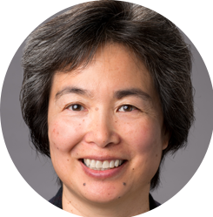 | CLOSING KEYNOTE  Mike Schroepfer, CTO, Facebook in conversation with  Tsu Jae King Liu, UC Berkeley’s Dean of Engineering  Year-end project/reflection paper due by end of week | 12.03.19 @6:30pm in Li Ka Shing Auditorium

CONTACT INFORMATION

Instructors: | Victoria Howell | vhowell@berkeley.edu
Student Coordinator (Questions on Attendance, Grading, Reports, Absences): | Swetha Prabakaran | swethapraba@berkeley.edu

OFFICE HOURS & COMMUNICATIONS
Contact Swetha Prabakaran ((swethapraba@berkeley.edu) for class-related questions, to schedule an office appointment. All communications available via B-course.

FORMAT
The course is a series of in-person lectures from leading innovators and entrepreneurs.Unless otherwise noted (via email and on b-course), classes take place each Tuesday, in Li Ka Shing Auditorium from 6:30pm – 8:00pm. There are three mandatory elements to this class and needed for a passing grade:
- Attendance is mandatory (Please note that it is not acceptable to arrive past 6:45pm, nor to leave early unless you have offered a written excuse prior to class. See policy for any absences below.
- Post class feedback forms (electronic) are mandatory.
- Written refection project due at the end of the semester with participants chosen at Networking Class mid semester. Details to be provided midway through the course.

There are also optional elements to the class as follows:
- You may be eligible to introduce one of our speakers
- You are encouraged to ask questions, during the Q&A period after the lecture, chat or panel.
- You may approach the stage, depending on speaker availability for a one-on-one interaction with the speaker/speakers

TOPICS COVERED
Leading entrepreneurs and innovators and c-level executives provide career insights, life lessons and their perspective on innovation in their field. Speakers are invited based on their contributions, diverse backgrounds and various perspectives on innovation and entrepreneurship.

CREDIT
This is a one-credit course, offered either for a grade or pass/fail. Passing marks and grades are based on mandatory in-person lecture attendance, completion of lecture feedback forms and report or project due at the end of the semester.

TEXTS AND REQUIRED SUPPLIES
In addition to in-person lectures, it’s recommended that students familiarize themselves with each week’s speaker and his/her business topic area prior to the speaking date.

GRADING & ATTENDANCE
65% - Attendance is mandatory and will be measured either via ID scan, “sign-in” sheets, electronic survey submissions due after each lecture or a combination.
35% - Mandatory group report/project. To be clarified mid semester.

ATTENDANCE POLICY
Attendance is mandatory for a passing grade. Please note: Excused absences must be submitted to our GSI in writing prior to or within 24 hours of the lecture. Each absence will be judged on a case–by–case basis, and you will receive instructions. If you cannot attend, submit a written excuse, prior to the lecture, or within 24 hours to:

Swetha Prabakaran (swethapraba@berkeley.edu )

Each unexcused absence will drop you one grade, for example from A to B, B to C. If you have a C for attendance you will not pass the class.

DATES & LOCATION
Students are to reserve Tuesday evenings, 6:30pm – 8:00pm. Our lectures will take place on campus at Li Ka Shing Auditorium, at University Crescent/Oxford. Please see b-course for updates.

